**Activity:** Cancer Cells and the Mitotic Index

AP Biology

Cell division is a highly regulated process that occurs in a cyclical manner. Not all cells divide at the same rate, though. Some cells, such as epithelial cells that make up the lining of the mouth and the outer layers of skin, divide fairly regularly and quickly. Other cells, like brain and muscle cells, do not divide at all once they have formed and remain in a nondividing state known as G0. Still other cells divide at regular intervals. Regardless of type, all cells undergo a regulated process in order to divide. When the regulation of cell division fails, uncontrolled cell division can result, leading to the formation of tumors.

A normal cell cycle looks like this, with checkpoints at certain stages of the cycle that determine whether or not the cell can proceed from one stage to the next. If the cell is able to meet the requirements of that checkpoint, then it proceeds into the next stage.

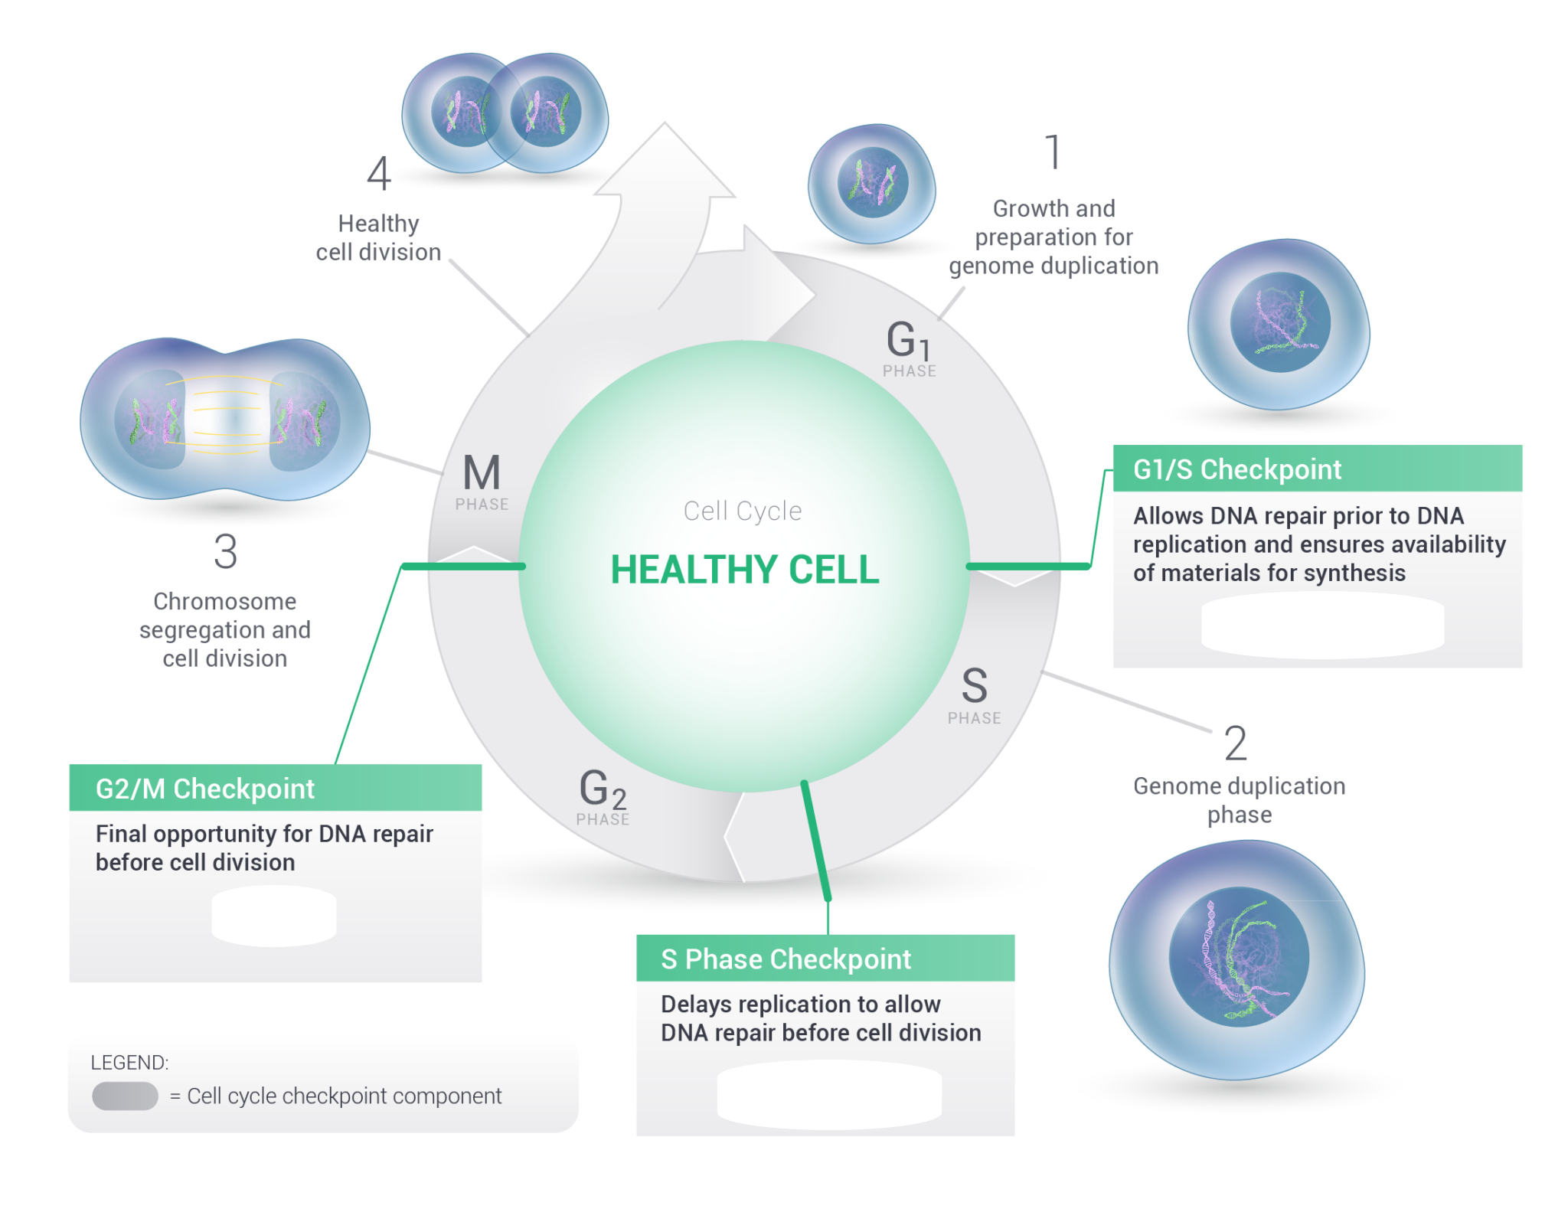

*image modified from* [*https://www.sierraoncology.com/wp-content/uploads/2016/12/Sierra-DDR_figure-3-web-desktop.png*](https://www.sierraoncology.com/wp-content/uploads/2016/12/Sierra-DDR_figure-3-web-desktop.png)

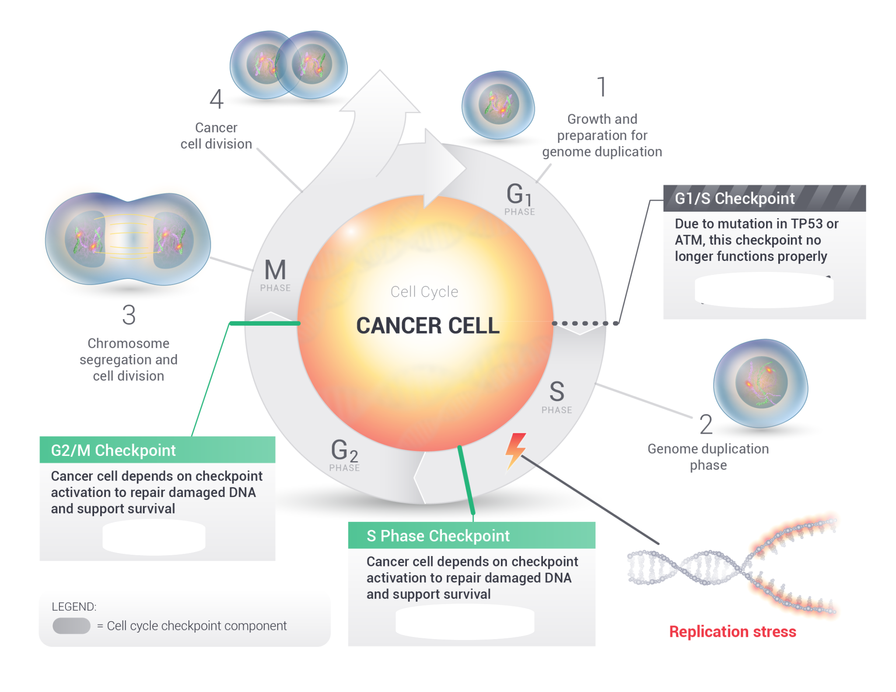

*image modified from* [*https://www.sierraoncology.com/wp-content/uploads/2016/12/Sierra-DDR_figure-4-web-desktop.png*](https://www.sierraoncology.com/wp-content/uploads/2016/12/Sierra-DDR_figure-4-web-desktop.png)

Each checkpoint is controlled by genes that produce proteins that regulate the activities of each checkpoint. If any one of the genes that controls the checkpoint is mutated or damaged in some way, then the cell is unable to meet the requirements of the checkpoint and the cell can become cancerous.

Cancer cells divide uncontrollably due to a lack of regulation. As shown in the figure above, you can see that if the first checkpoint--regulated by the p53 gene, also called the “master regulator”--is not functioning properly, the remaining checkpoints cannot function properly either and the cell will divide without passing the requirements there.

How many cells in a given area of tissue are undergoing division at a given time can be measured by calculating the mitotic index. The mitotic index is a measure of how many cells in a given tissue are dividing compared to the cells that are not dividing. It is calculated by taking the number of cells in mitosis and dividing that number by the total number of cells. To be able to identify cells that are dividing from cells that are not, you must know what the stages of mitosis are compared to what a cell in interphase looks like. The figure on the next page will show you.

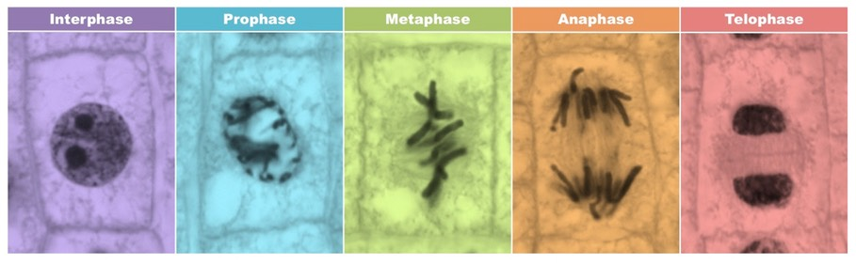

*image source:* [*https://ib.bioninja.com.au/standard-level/topic-1-cell-biology/16-cell-division/mitotic-index.html*](https://ib.bioninja.com.au/standard-level/topic-1-cell-biology/16-cell-division/mitotic-index.html)

Remember that interphase includes the preparation for division and is NOT actually a resting phase. It comprises the G1, S and G2 phases. Mitosis is prophase, metaphase, anaphase and telophase.

**DIRECTIONS:**

1. Pull up the [Google Slides](https://docs.google.com/presentation/d/1-j17MOfi0Qkd1pteZFfTwyqzZ6emI4NDzmNzyoKh8sc/edit?usp=sharing) containing the cell specimens. You’ll also find the slide presentation in Canvas.
2. For each slide, count the number of cells in interphase and record the number of those cells in the data table.
3. Then, count the number of cells in **any other phase** of mitosis--you are not counting them by WHAT phase they’re in, just that they’re in mitosis. Record this number in the data table as well.
4. Calculate the mitotic index for each tissue. This is done by dividing the number of cells in mitosis on the slide by the TOTAL number of cells on the slide.
5. Determine whether or not the cells on the slide are normal or cancerous based on the mitotic index. A higher mitotic index indicates that cell division is taking place at a higher rate in that tissue than in a tissue with a lower mitotic index.

**Data Collection**

| Sample | # of cells in Interphase | # cells in **any other** phase of mitosis | Mitotic Index: # of cells in mitosis / total  # of cells | % cells  Dividing | Normal or Cancer? |
| --- | --- | --- | --- | --- | --- |
| Slide A: Ovary |  |  |  |  |  |
| Slide B: Ovary |  |  |  |  |  |
| Slide C: Stomach |  |  |  |  |  |
| Slide D: Stomach |  |  |  |  |  |
| Slide E: Brain |  |  |  |  |  |
| Slide F: Brain |  |  |  |  |  |
| Slide G: Lung |  |  |  |  |  |
| Slide H: Lung |  |  |  |  |  |
| Slide I: Pancreas |  |  |  |  |  |
| Slide J: Pancreas |  |  |  |  |  |
| Slide K: Prostate |  |  |  |  |  |
| Slide L: Prostate |  |  |  |  |  |

**QUESTIONS:**

1. What does your data show about the rate of cell division in cancerous tissue compared to the rate of cell division in normal tissue? What data can be used to support your answer to this question?
2. Which type of cancer is the fastest growing? **Explain** your answer, using relevant data to support your claim.

**Part 2:** [**Chi-Square Test**](https://youtu.be/WXPBoFDqNVk)

Now you will calculate a chi-square value for each of the tissue types in the lab. Remember that a

chi-square test is done to see if there is a statistically significant difference between what is observed and what is expected. Before you begin running the test, you must first establish a null hypothesis and an alternative hypothesis. Then, calculate the chi-square value for each of the tissue types. Determine what the degrees of freedom are for each data set, and then evaluate your result based on the calculated chi-square value and the critical values table found on the next page. 

For this activity: think about what a doctor would **EXPECT** to see in the tissues of a healthy individual.

| **Null hypothesis:** |  |
| --- | --- |
| **Alternative hypothesis:** |  |



Table 1: Ovary Cells

|  | Obs | Exp | Obs-Exp | (Obs-Exp)2 | (Obs-Exp)2/ Exp |
| --- | --- | --- | --- | --- | --- |
| Cells in interphase |  |  |  |  |  |
| Cells in mitosis |  |  |  |  |  |
| Total |  |  |  |  |  |

Degrees of freedom:

Table 2: Stomach Cells

|  | Obs | Exp | Obs-Exp | (Obs-Exp)2 | (Obs-Exp)2/Exp |
| --- | --- | --- | --- | --- | --- |
| Cells in interphase |  |  |  |  |  |
| Cells in mitosis |  |  |  |  |  |
| Total |  |  |  |  |  |

Degrees of freedom:

Table 3: Brain Cells

|  | Obs | Exp | Obs-Exp | (Obs-Exp)2 | (Obs-Exp)2/Exp |
| --- | --- | --- | --- | --- | --- |
| Cells in interphase |  |  |  |  |  |
| Cells in mitosis |  |  |  |  |  |
| Total |  |  |  |  |  |

Degrees of freedom:

Table 4: Lung Cells

|  | Obs | Exp | Obs-Exp | (Obs-Exp)2 | (Obs-Exp)2/Exp |
| --- | --- | --- | --- | --- | --- |
| Cells in interphase |  |  |  |  |  |
| Cells in mitosis |  |  |  |  |  |
| Total |  |  |  |  |  |

Degrees of freedom:

Table 5: Pancreas Cells

|  | Obs | Exp | Obs-Exp | (Obs-Exp)2 | (Obs-Exp)2/Exp |
| --- | --- | --- | --- | --- | --- |
| Cells in interphase |  |  |  |  |  |
| Cells in mitosis |  |  |  |  |  |
| Total |  |  |  |  |  |

Degrees of freedom:

Table 6: Prostate Cells

|  | Obs | Exp | Obs-Exp | (Obs-Exp)2 | (Obs-Exp)2/Exp |
| --- | --- | --- | --- | --- | --- |
| Cells in interphase |  |  |  |  |  |
| Cells in mitosis |  |  |  |  |  |
| Total |  |  |  |  |  |

Degrees of freedom:

Critical Values Table: Remember to read the table for a P value of p = 0.05.

